How to Complete Your Scientific Literature Review Matrix
Portions adapted from Writing a Literature Review University of Guelph
https://www.lib.uoguelph.ca/get-assistance/writing/specific-types-papers/writing-literature-review

Literature Review Definition
A literature review is both a summary and explanation of the complete and current state of knowledge on a limited topic as found in academic books and journal articles. There are two kinds of literature reviews you might write at university: one that students are asked to write as a stand-alone assignment in a course, often as part of their training in the research processes in their ﬁeld, and the other that is written as part of an introduction to, or preparation for, a longer work, usually a thesis or research report.

Freshmen students in the STEM program will compile a list of resources and complete a literature review matrix to assist their science fair research design.

Sophomore students in the STEM program will compile a list, complete a matrix, and write a literature review as part of a longer research paper that details the entire science fair project.

Purpose of the Literature Review
- It gives readers easy access to research on a particular topic by selecting high quality articles or studies that are relevant, meaningful, important and valid and summarizing them into one complete report
- It provides an excellent starting point for researchers beginning to do research in a new area by forcing them to summarize, evaluate, and compare original research in that speciﬁc area
- It ensures that researchers do not duplicate work that has already been done
- It can provide clues as to where future research is heading or recommend areas on which to focus
- It highlights key ﬁndings
- It identiﬁes inconsistencies, gaps and contradictions in the literature
- It provides a constructive analysis of the methodologies and approaches of other researchers

Steps To Completing A Literature Review Matrix:

1. Find a Working Topic
Look at your speciﬁc area of study. Think about what interests you, and what is fertile ground for study. Talk to your advisers, brainstorm, and read lecture notes and recent issues of periodicals in the ﬁeld. Do an internet search for “Calls for Research” or “Broad Agency Announcements” to help you find a topic.

2. Find the Literature
Begin with Cobb Virtual Library databases available through the county.
- Go to www.harrisonhigh.org
- Under the Student Support tab, choose Learning Commons
- Under Online Resources, choose Cobb Digital Library
- You will be redirected to cobb.mackinvia.com
  - School: HARRISON HIGH SCHOOL, KENNESAW, GA
  - User Name: your student number
  - Password: read—or the password you use for school computers
- Under the GROUPS tab, choose Databases.
- Open the database Academic Search Complete.

How to Use Database Search Tools
- VIEW THIS VIDEO!!! https://www.youtube.com/watch?v=4dOICAZlMbc
- Before entering keywords into the search bar, click the Advanced Search option under the search bar.
- In the Search options, choose Boolean/Phrase, Also Search Related Words, Also Search Within Full Text, Full Text. (See figure below.)

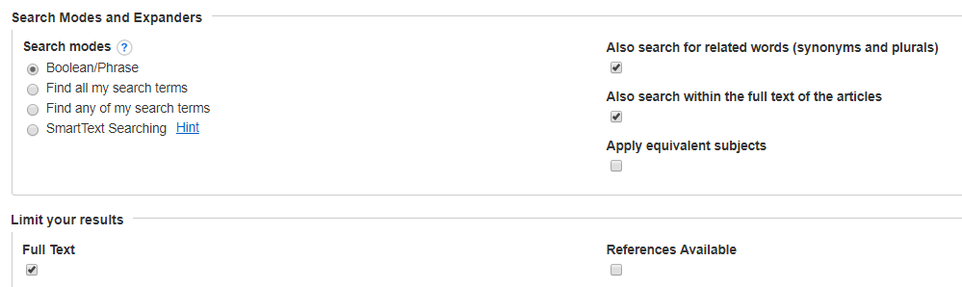

- Enter keywords and restrictors into the search bar.
- Choose articles that scientists have written to detail their own scientific studies. You may read articles that give you general information about your topic, but these are NOT included in the literature review. You are looking for scientific RESEARCH articles.
- Remember that the reference lists of recent articles and reviews can lead to valuable papers
- Make certain that you also include any studies contrary to your point of view

3. Read the Selected Articles Thoroughly and Evaluate Them
- What assumptions do most/some researchers seem to be making?
- What methodologies do they use? What testing procedures, subjects, material tested?
- Evaluate and synthesize the research ﬁndings and conclusions drawn
- Note experts in the ﬁeld: names/labs that are frequently referenced
- Note conﬂicting theories, results, methodologies
- Watch for popularity of theories and how this has/has not changed over time

4. Complete the Cells in the Matrix
- Article Title and Link Copy the entire article title and the URL
- Citations While you are in the database, click on the CITE icon on the right side of the article in the database. Find the APA citation, copy and paste it in under Citations on the bottom of the matrix.
- Theoretical/Conceptual Framework Identify the scientific field of study and the theory the study is working from/against.
- Research Question(s)/Hypothesis Identify the question and hypothesis of the study.
- Methodology Describe the research process the scientist used to gather data.
- Analysis & Results Describe the results of the scientist’s data.
- Conclusions Describe the conclusions the scientist made after analyzing the data.
- Implications for Future Research Identify the work the scientist suggests should be done to further the study. If it is not directly stated, suggest next steps that could be taken.

